Case Name:

County: Case No:

**Firearm Identification Worksheet**  
(*You may attach this to the petition*.)

1. Does the restrained person own or have access to any firearms? [ ] Yes [ ] No

2. Does the restrained person have a concealed pistol license (CPL)? [ ] Yes [ ] No

3. When was the last time you saw the firearm/s?

4. Do you know where the restrained person keeps the firearm/s? [ ] Yes [ ] No

If yes, check all that apply:

[ ] On their Person [ ] In their Car [ ] In their Home [ ] Storage Unit [ ] In a Safe

5. To the best of your knowledge, are the guns typically loaded?

[ ] Yes [ ] No [ ] I don’t know

6. On a scale from 1 to 5 (1 being “not very important and 5 being “very important”), how important are the firearms to the restrained person?

1 2 3 4 5

7. What does the restrained person generally use the firearms for? (*check all that apply*)

[ ] Hunting [ ] Collecting [ ] Target Shooting [ ] Protection [ ] Other:

8. Does the respondent possess explosives? [ ] Yes [ ] No [ ] I don’t know

9. Has the restrained person ever ordered parts of firearms or possess parts that could be assembled into a working firearm? [ ] Yes [ ] No [ ] I don’t know

10. Does the restrained person own or possess any other dangerous weapons you believe should be surrendered? [ ] Yes [ ] No If yes, list them here:

The pictures below are examples of the most common guns. If you recognize any of the pictures below as similar to the one/s your partner has, please circle it and write in the circle how many your partner has.

**Handgun**

|  |  |  |
| --- | --- | --- |
|  |  | |
|  | |  | |

|  |  |
| --- | --- |
|  |  |

**Semi-automatic Rifle**

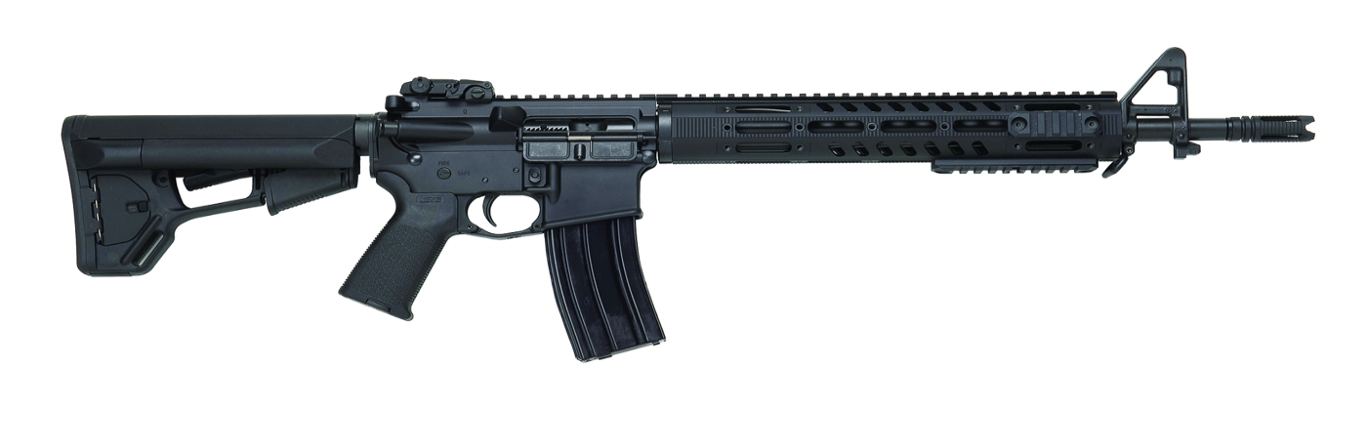

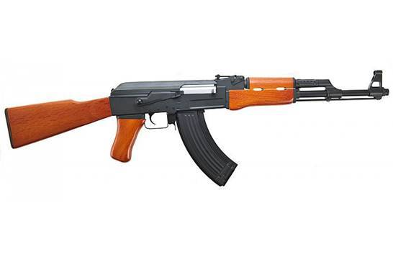

**Rifle**

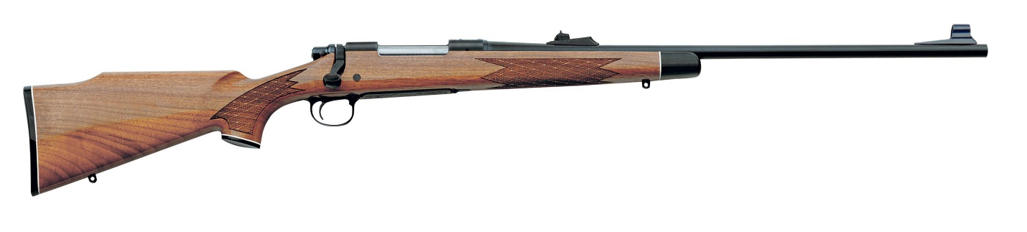

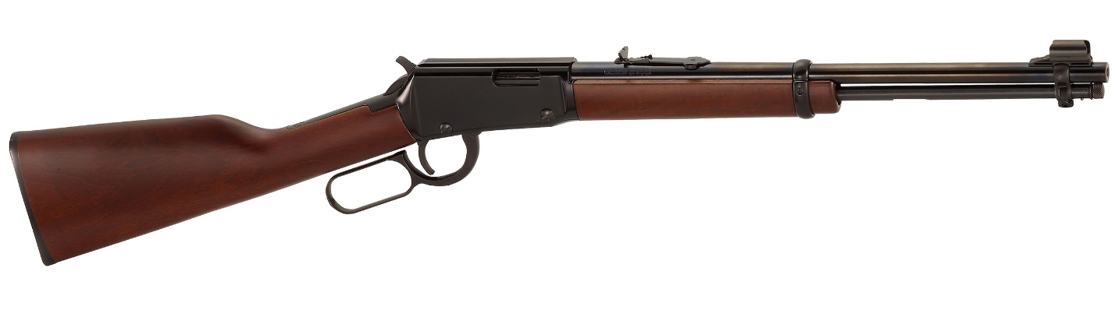

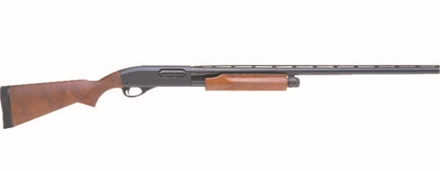

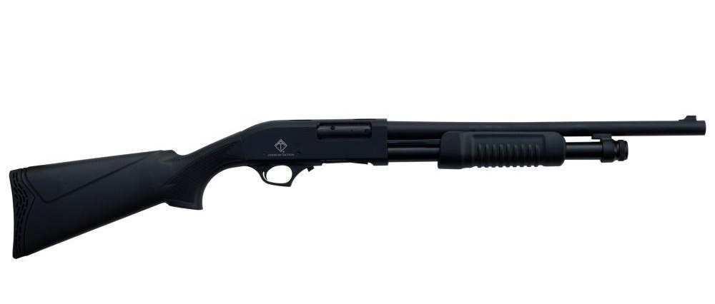

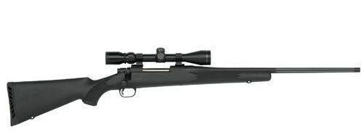

**Unassembled Firearms**

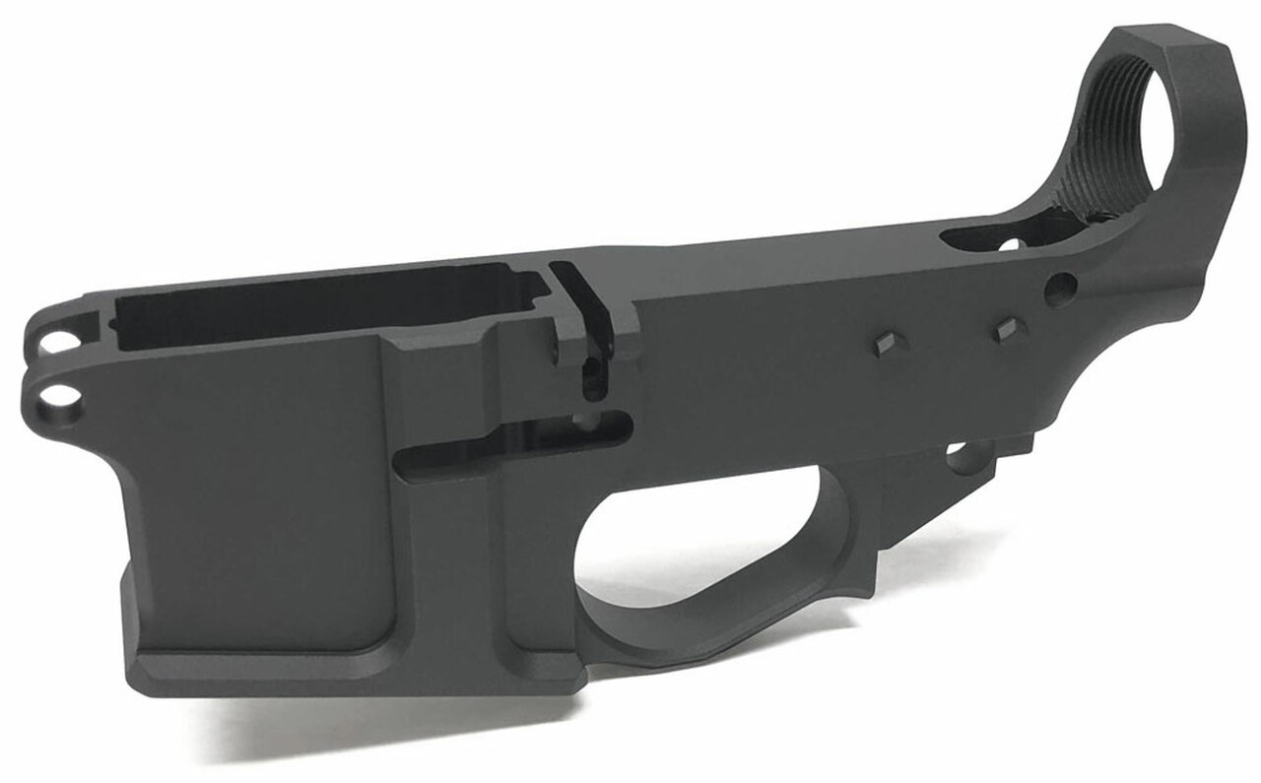

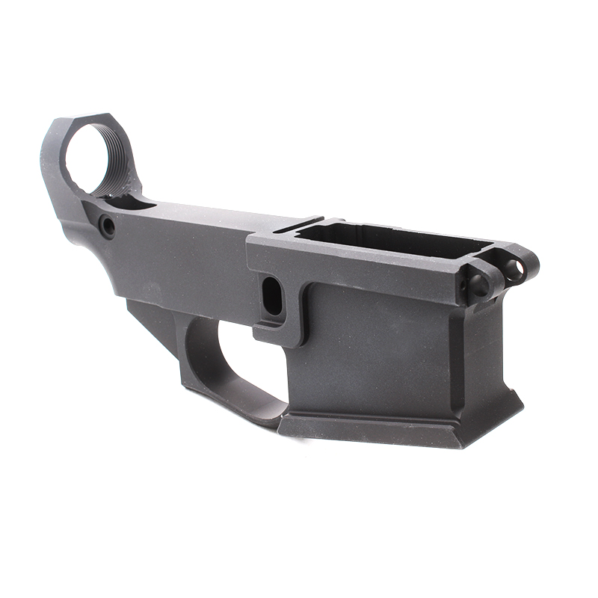

Signed Dated